horizontal line

**Brodie Armstrong**

**Beth Emborsky**

Flu Influences by Weather

**25th June 2020**

# Relationship Between ILI Cases and Temperature

It is clear that temperature has an impact on how many cases of influenza-like illness (ILI) were diagnosed in the all the cities in the U.S. that we examined. Each year, as the average temperatures started to get colder in the winter months, the number of reported flu cases increased. Here is the city of Chicago’s data showing this relationship:

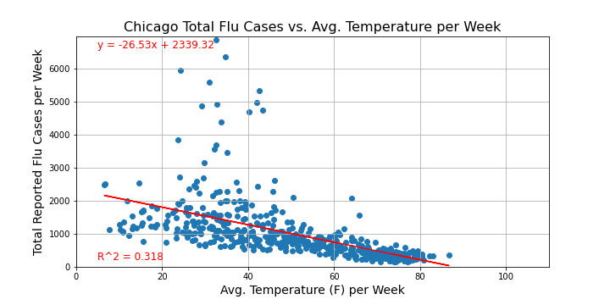

# Relationship Between ILI Cases and Precipitation Totals

Unlike temperature, precipitation totals did not show any trend associated with cases of influenza-like illness in all the cities in the U.S. that we examined. Here is Chicago’s data showcasing no real trends:

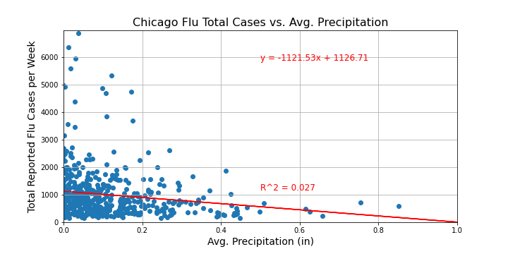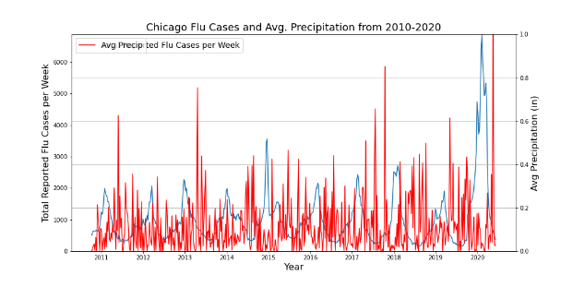

# Relationship Between Total Positive Flu Tests and Temperature

As expected, the average number of positive flu tests per week was shown to have the same trend as the reported ILI numbers did above. Here is Chicago’s data to show the similar trend:

